
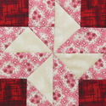
Anderson County
Piecemakers Quilt Guild
Newsletter

VOLUME 18, Issue 17 January 2023
PRESIDENT – Joan Beard VICE-PRESIDENT- Marsha Cole
SECRETARY – Shelly Winsor TREASURER – Pat Miller
NEWSLETTER - Kay Scheffler MEMBERSHIP -
LIBRARIAN -

Hello all Piecemakers,
Wow can you believe it’s a New Year already?
We had a fantastic December meeting. Thanks, Marsha, for the Left Right story for our gift exchange We have two new members, Emily and Quentin Raisor. WELCOME to our group!
Fifty-one stocking were made, stuffed and delivered to the Senior Citizens Meals on Wheels Recipients.
Thanks to Linda and those who worked on this project.
Our January and February group is Betty Ann Sutherland, Donna Nicholette, Martha Morris, Kay McDaniel and Linda Marean.
As a reminder, if there is inclement weather and the schools are closed, we will NOT meet.
Our next meeting is TUESDAY, JANUARY 3rd. Project Day is on the 5th.
January birthdays are Glenna Smith - 14, Marcia Roth - 25. Happy birthday ladies!
Have a wonderful rest of 2022, looking ahead to 2023!
Joan B.

Dear Quilt Guild stocking elves – thank you so much for the wonderful stockings you helped sew together for our local Senior Citizens. We had a couple of stockings in hand, last week before they were filled. There were oohs and aahs from a couple at the Center as they rigorously “inspected” them. One of the comments was “how lucky our community is, to have people who care enough to do a project like this.”
You all have received warm hugs, and the stockings haven’t even been delivered, yet!
Appreciation also goes to members of the Senior Center Quilt Club for filling the stockings last Friday! Our amazing “elves” had everything filled and the room cleaned up in about 1 hour – Santa is ready to do some last-minute hiring! Interested? Our special, happy elves included Judy Howard, Linda Marean, Betty Jo Moss, Kay Scheffler, Mattie Spaulding, Betty Ann Sutherland, Carol Witthaus, Joan Beard, and Donna Jones. Heart-felt thanks go to all of you who participated in this activity and help make a difference in lives in our community. “Christmas lives in the hearts of those who give”. Thank you from Linda Marean

Update on Clara – She is finally home and doing well. Her birthday is January 8 the same as Elvis. Give her a jingle to brighten her day.
Joke/Riddle:
I am neither a guest nor a trespasser be, to this place I belong, it belongs also to me. (Answer at end)
Upcoming Events:
- January 17-21, Annual Jabez Quilt Seminar, Cave City Convention Center, laurel.ca.uky.edu.JQS
- April 13-14, It’s So Fine Sewing Expo, Boyle County Extension Office
- March 11, 9-3 – Quilters Day Out, Shepherdsville
- April 6, 2023, Anderson County Cultural Arts
- May 9-11, 2023, KEHA State Meeting, Crowne Plaza, Louisville, KY

December Meeting Minutes: Christmas meeting of the Anderson County Piecemakers Quilt Guild.
12/06/22 at 6:02pm at the UK Extension Building
Officers Joan Beard, Marsha Cole, Shelly Winsor, and Pat Miller present.
Joan called the meeting to order and invited members to share Christmas memories. Introduction and welcome of guests. Mattie is the only December birthday. Treasurer’s report: available balance of $1459.97.
Fifty-two Christmas stockings finished for seniors. Joan displayed a table of donations given from
outside sources for stocking stuffers. Announced bidding on Christmas stockings submitted by members. Pat Miller’s stocking had the most bids.
Sew and Tell - Members shared the various projects they’ve been working on.
Joan reminded us of the calendar schedule for monthly program chairs for January and February. Reviewed upcoming events and discussed those in need of prayers.
Marsha Cole discussed the request from the Sheriff dept. for 15 blankets for their patrol cruisers. Blankets quilted or store bought are fine and can be submitted to Marsha at any time.
We shared wonderful food brought by the members and had a great time socializing with each other.
We participated in a fun gift exchange and Linda directed us as we played Christmas songs with chimes.
Meeting ended at 8:24
Shelly Winsor, Secretary

More Sewing Safety

Whole Body Sewing Safety
Taking care of your body during and after sewing is very important. When you are at your sewing machine, make sure that you can sit with good posture and bend your elbow at a 90-degree angle parallel to the floor. You may have to adjust your chair or table height.
After sewing for a while, take time to stretch. Repetitive sewing activities like cutting, pressing and sewing build up tension in your body. It’s very important to stretch for self-care and to use techniques to have pain free. Here is an example of stretches to do before, during and after a sewing session. Yoga is a great practice to help release the body’s tension. We had a yoga instructor come and give a class. If there is interest, we can try this again.
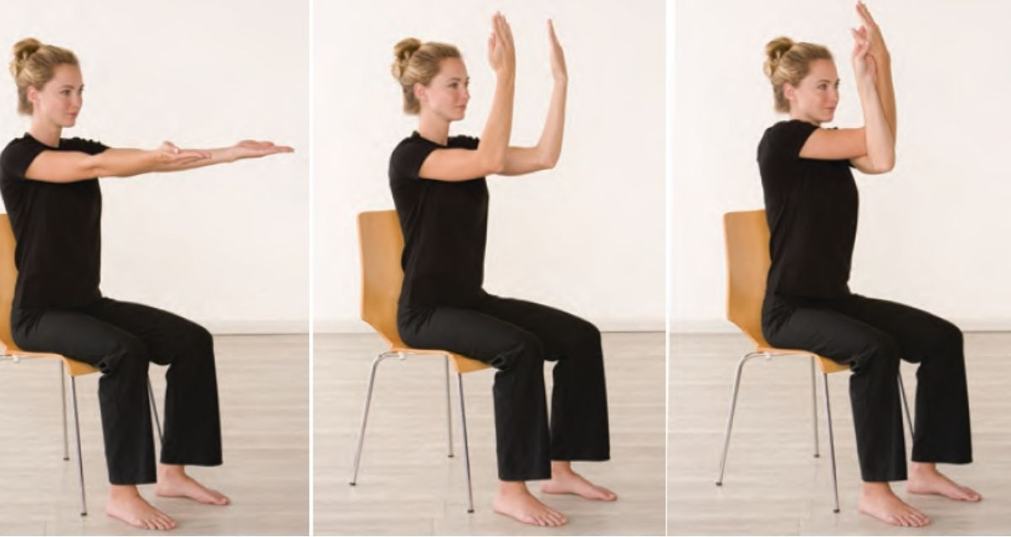

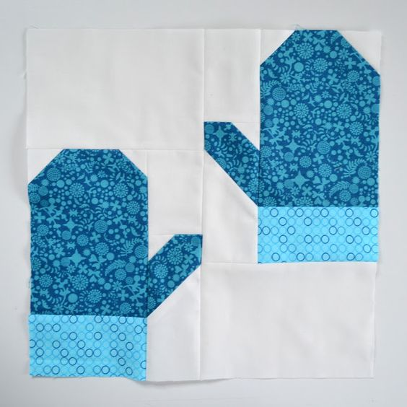
Answer to riddle: Home

